1. Get me IP address of a particular domain (guvi.in)

Using traceroute command & nslookup

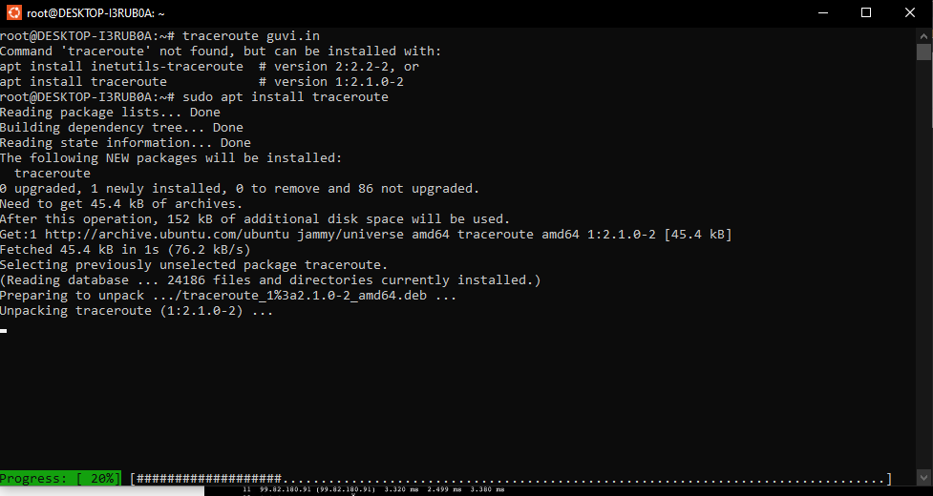

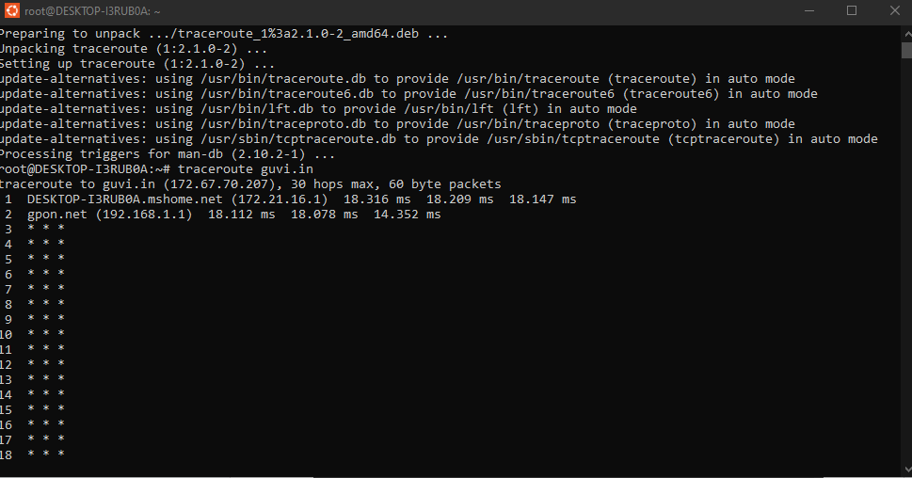

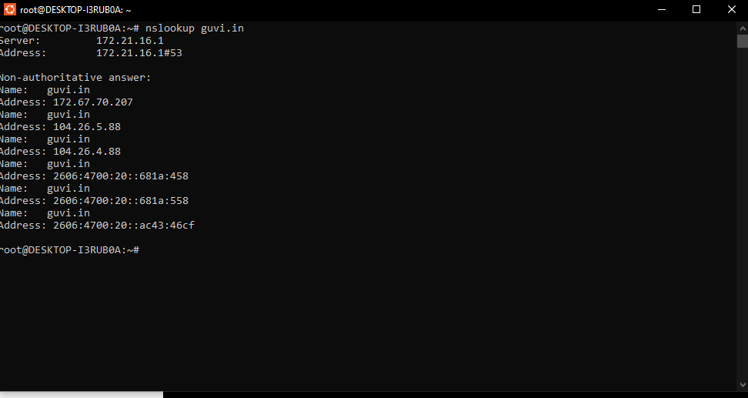

2. How do I find my CPU/memory usage of my server?

Using mpstat command

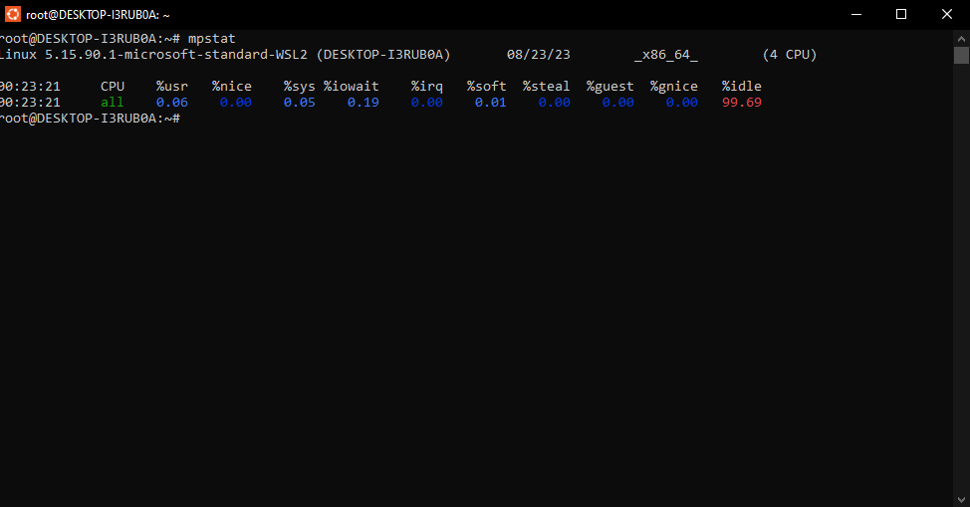

3. Test the connectivity between 2 nodes?

Using ping command

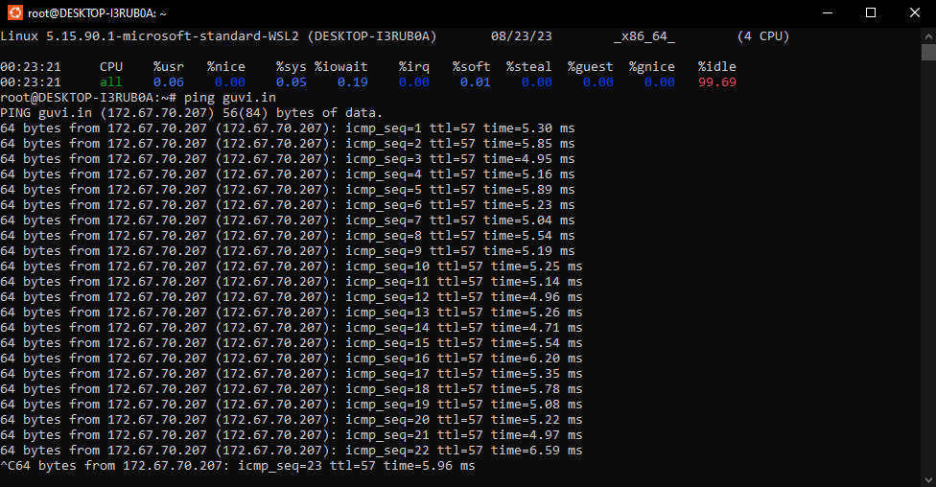

4. I have deployed an application in guvi.com:9000, and logs shows my app is running, but I’m unable to view the page. Check whether my port is open or not ?"

Using nmap command

